# Pressure Tank Report

This report is explanation of the calculations and measuring the distance of the pressure tank gun we are building.

# Prerequisite to the report

We are making a water gun that needs to shoot at least 6 meters. Therefore, we have bought a pump that Tolga and Nikita are testing, but to explore more options, we are currently trying to build a reverse bottle rocket, where we hold the bottle part still, and shoot out water.

We have a goal of making the bottles hold 50PSI of pressure, that would have an exit velocity of 22m/s according to Radu’s calculations of the bottle. You can see the calculations here:

Et billede, der indeholder tekst, håndskrift, blæk/sværte, papir

Indhold genereret af kunstig intelligens kan være forkert.

# First and second try

Our first try we build them like you would normally a bottle rocket, where we tried to just glue the valve and the one-way valve for the pressurization. Here is the pictures and a small explanation off why it didn’t work:

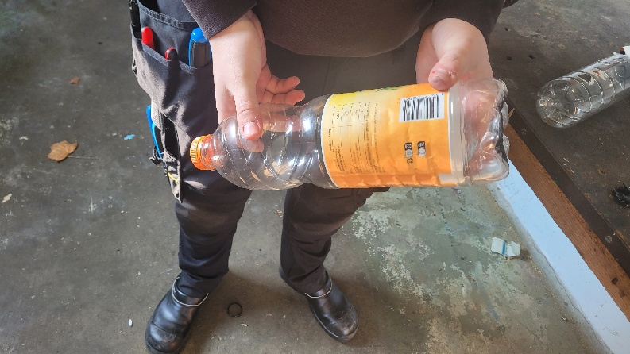Et billede, der indeholder maskine, Metalarbejde, bore/bor, Maskinværktøj

Indhold genereret af kunstig intelligens kan være forkert.

Et billede, der indeholder værktøj, person, Maskinværktøj, jord

Indhold genereret af kunstig intelligens kan være forkert.

This was all very great, the idea was good, but the execution was a bit off. It did hold the pressure up until 10PSI. but after that it blew out the glue from the cap. This was because the glue doesn’t stick on “fatty plastics” which this is, because it’s made from PP (polypropylene), and PET (which is the rest of the bottle) is not a fatty plastic. Meaning the glue stuck great for the one-way valve, but the release valve was not good.

Therefore, we decided to make a bottle that only was glued on the PET bottle.

This looked like this:

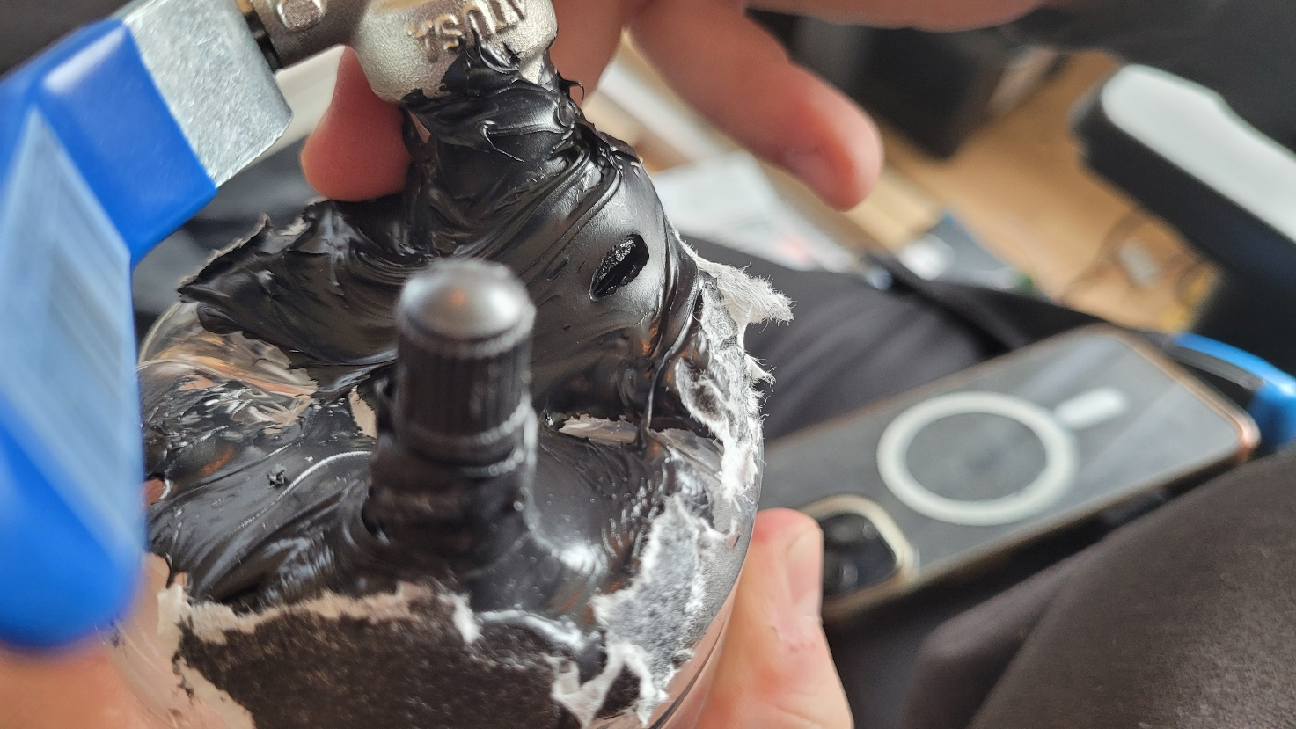

Et billede, der indeholder person, indendørs, blender, Laboratorieudstyr

Indhold genereret af kunstig intelligens kan være forkert.

This was a bit better at a whopping 12PSI of pressure before bursting the glue open, spewing water everywhere. This was better, but still not ideal. Therefore, we were thinking a bit outside the box. We tried to sketch up ideas of welding a steel pressure tank together. Usually, the only steel tanks that we could buy would be rather heavy (exciting the weight of max 11kgs) and have a very large capacity, which was not needed.

Therefore we looked into other types of tanks;

# Pressure tanks made from PVC pipe.

We took a lot of inspiration from different sources, but the thing we were looking at was other people successfully storing 80-120PSI of pressure in air cannons, the concept looking very similar to what we are building. The main youtube video “guide” we follow was this;

Et billede, der indeholder cylinder, indendørs, lampe, gulv

Indhold genereret af kunstig intelligens kan være forkert.

<https://www.youtube.com/watch?v=NvH9WHNxvj8>

Unfortunately, we didn’t manage to build this type of tank before we found new and better ideas. And even more unfortunately we can’t glue the end blinds to the tubes because of the university’s strict “no harming students” policies. Therefore, we decided to keep exploring other options.

# 3D printed tank

Firstly we didn’t think that the 3D printed tank was going to work, generally is 3D printed things not going to be water tight (or gas tight) therefore we never thought this was going to work, that was before we saw this video:

Et billede, der indeholder tekst, skærmbillede, software, Multimediesoftware

Indhold genereret af kunstig intelligens kan være forkert.

<https://www.youtube.com/watch?v=ZB6VbkeYrkw>

this shows that there is very much a potential for this to work, some of his restrictions in his work was he couldn’t get a non leaking version of his design, therefore we looked into other things.

Et billede, der indeholder apparat/anordning, Måleinstrument, måler, jord

Indhold genereret af kunstig intelligens kan være forkert.

This video showed a similar pressure tank design that is leak free and is made from ABS plastic instead of PLA.

It is also vapor smoothed with acetone. This is not feasible on school ground but smoothing and using acetone the more “standard way” of just brushing it on with a paintbrush. This Is more possible.

We tried to first print a model so we could see if this worked for us, that’s where Tobias 3D printed the first model on his own printer and afterwards mounted all the hardware (one way valve and the release valve) this worked very well, even though it was very leaky. It held up to 100PSI (He didn’t dare go higher than that for now)

We then decided to try and 3d print a bigger one, with more walls (because the original one only had 2 walls on the inside, then 30%infill and then 2 walls again) so we didn’t have much confidence in its strength if we decided to move forward with more testing. Therefore, we simply printed the same thing again, but this time with 12 walls in total, really making sure that it was watertight.

(12 walls is not needed for the final design we don’t think, as you saw in the YouTube videos, 4 or even 6 walls is more than enough to hold a lot of pressure, but what we want to make sure in our testing is that we don’t have premature leaks or blowouts, before we have a safety valve ( a valve that will let our pressure before it builds up to be to much) also having very many walls means that we rather safely can go up in pressure if we find that the pressure we need is bigger than the 50PSI that we originally design the pressure tank for. Therefore, while we can do testing, we should not have less than a safe number of walls.)

Introduction of Barometer

We want in the final product to be able to reproduce the pressure without having to look at the actual compressor’s barometer (because that requires manual labor) so therefore we want to add a barometer in to the tank area. This is of course a really difficult task because we still want the tank to be able to hold pressure but also be able to have wires going into the tank (fuck going wireless, that shit never works reliably when you want it to, or at least its like schrodingers cat, where it works before the exam, but at the exam the cat is dead, beaten up and mario has fucked it)

Therefore we have designed at small squared opening, which we can close with a end cap, which is ment to be screwed in with 8 x m3 bolts, with a pullout strength of 1304N pr thread[1] we can effectively hold

Et billede, der indeholder tekst, skærmbillede, Font/skrifttype, nummer/tal

Indhold genereret af kunstig intelligens kan være forkert.

Which in turn means that this in theory can hold upwards of 1600 PSI of pressure[2]

This is because we use threaded heat inserts in the PLA. That will give us both a very usable thread (which printing thread is not) and something that is very strong and can be screwed on and off a butt load of times.

This is ofc not something we expect to be able to hold, because we are still only using plastic as the lid for this, and that will probably bend before it reaches that pressure. But this gives us some theoretical which we can work with. That means the design is probably good enough.

We will need to print a 3D gasket made from TPU to be able to seal the lid against the rest of the container. I am lucky that I have some at home, and therefore I can just print it, and not have to wait for the guys in the 3D printing lab to be done with it.

The lid gasket as we will call it from now on, we will firstly try and print with normal 80A Tpu (the softes you can get from normal places like 3DEksperten) but we have also but Olga (the 3d printing nerds) to print it from a silicon like material (the one that uses pellets in the lab)

Also, I think the only correct filament to use, that has a lessor bending, is PETG (Carbon fiber variant) that is a lot stiffer (so that it doesn’t bend where we don’t have any screws) which is powerful for what we want to have. [3] But ofc we will still do testing with PLA before we make assumptions about the strength of it, especially when it’s 100% infill.

This design ultimately proved to be a failure, here is the breakdown for you:

Barometer

Initially I read the spec sheet of the barometer wrong, and in turn I thought that the rated pressure was from 0 to 1100 MPa. Which is high enough for our purpose, but the rating was in hPa, which in turn lead it to have a maximum pressure reading of just over 15.9PSI of pressure. That would not work for our idea, and the pressures that we were trying to hit. Therefore, we completely dropped the idea of pressure reading, rather relying on a mechanical valve to regulate the pressure, this would also prove later to be a good idea when doing pressured air.

Tank lid design

Ultimately having a hole in your pressure tank is not a good idea, of course there are pressure vessels that have lids and other sealing types on them, but in general if you want good long-term reliability, the easiest thing is just to not have a hole there, rather building a modular system, instead of having a pressure reading In the tank itself, have it in the outlet system of the 1/2 inch tube fittings. This would ultimately be better not only because it is modular and therefore need less prints of the tank itself. But also, very adaptable in all the situations we could be in.

# Calculating Maximum pressure

Et billede, der indeholder tekst, skærmbillede, Font/skrifttype, dokument

Indhold genereret af kunstig intelligens kan være forkert.

1. <https://www.3dpeople.uk/threaded-inserts-service>
2. <https://www.sensorsone.com/psi-to-n-mm2-conversion-table/>
3. <https://recreus.com/en/blogs/learn-with-recreus-1/petg-vs-petg-cf?srsltid=AfmBOorQgLTRYAOTMJwPNqv9xJjSbAmjMWTuv95hvxeYaDrdOLF3XVQH>